Practical No 06

VIII. Resources required (Additional)
- If any web references are required.

Resources used (Additional)
  - https://docs.microsoft.com/en-us/dotnet/visual-basic/language-reference/statements/while- end-while-statement
  - https://docs.microsoft.com/en-us/dotnet/visual-basic/language-reference/statements/do- loop-statement

Program Code
Write a program using While & Do loop in VB.Net
- For while loop.
Module Module1

Sub Main()
Dim a As Integer = 1 While (a < 10)
Console.WriteLine(a) a = a + 1
End While Console.ReadLine()
End Sub

End Module

Output:
1
2
3
4
5
6
7
8
9

For Do loop.
Module Module1

Sub Main()
Dim a As Integer = 1 Do
Console.WriteLine(a) a = a + 1
Loop While (a<10) Console.ReadLine()
End Sub

End Module

Output:
1
2
3
4
5
6
7
8
9

Practical Related Questions
  - Differentiate between Do & While Loop statements in VB.Net
No Do Loop No While Loop
In Do loop, the condition can be tested

1 at starting or ending as per requirement.
For Do Loop two variation available
2
Do While Loop & Do Until Loop
Do While Loop statement can execute for finite number of iterations as long
as condition of loop is true while Do
3
Until Loop statement can execute for
finite number of iterations as long as condition of loop is false.
Loop keyword is used as termination
4
statement for Do loops.
Dim index As Integer = 0 Do
Debug.Write(index &
index += |  |  | 1
 | Until | index > |  | 10

" ")
5 Loop
In While loop, the condition can be
1
tested at starting only.

For While loop no such variations are
2
available.

While loop can execute for finite
3 number of iterations as long as condition of loop is true.

End keyword is used as termination
4
statement for While loop.
Dim index As Integer = 0 While index <= 10
Debug.Write(index & " ") 5 1
index +=
End | While

Debug.WriteLine("")
' Output: 0 1 2 3 4 5 6 7 8 9 10
Debug.WriteLine("")
' Output: 0 1 2 3 4 5 6 7 8 9 10

Give the syntax of While & Do loop statements in VB.NET.
- While Loop:
It executes a series of statements as long as a given condition is True.

Syntax:
While condition [ statements ]
[ Continue While ] [ statements ]
[ Exit While ] [ statements ]
End While

Do Loop:
It repeats the enclosed block of statements while a Boolean condition is True or until the condition becomes True. It could be terminated at any time with the Exit Do statement.

Syntax:
Do
[ statements ]
[ Continue Do ] [ statements ]
[ Exit Do ]
[ statements ]
Loop { While | Until } condition

rcise
  - Write a program using While statement to print the prime numbers between 1 to 100.
Module Module1 Sub Main()
Dim i, j, c As Integer c = 0
i = 2
While (i <= 100) j = 2
While (j < i)
If (i Mod j = 0) Then Exit While
ElseIf (i = j + 1) Then Console.WriteLine(i)
End If
j = j + 1
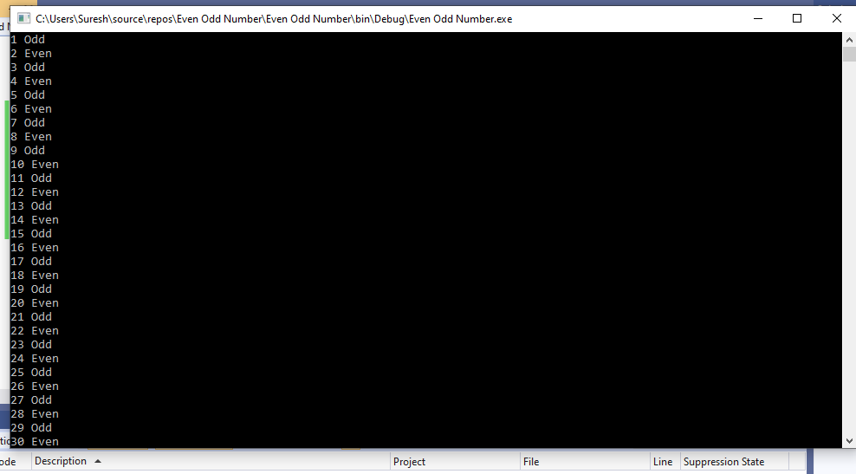
End While
i = i + 1 End While
Console.ReadLine() End Sub
End Module

OUTPUT:

Write a program using While statement to print even-odd numbers between 1 to 50.
- Module Module1

Sub Main()
Dim i As Integer = 1 While (i <= 50)
If ((i Mod 2) = 0) Then Console.WriteLine(i & " Even")

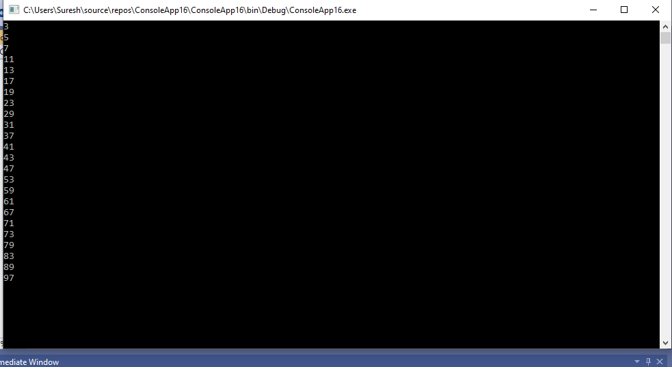
Else
Console.WriteLine(i & " Odd")
End If
i = i + 1 End While
Console.ReadLine() End Sub

End Module
Output:

